
ISTANBUL TECHNICAL
0
1
UNIVERSITY

COMPUTER ENGINEERING

DIGITAL CIRCUITS LABORATORY
EXPERIMENT REPORT

EXPERIMENT NO: 2

EXPERIMENT NAME: IMPLEMENTATION OF COMBINATIONAL CIRCUITS

EXPERIMENT DATE : 08.03.2013

GROUP NO: 6

STUDENTS WHO DID THE EXPERIMENT:

Student no Name Surname

040100113 MUSTAFA UÇAR
040100117 TUĞRUL YATAĞAN
040100124 EMRE GÖKREM

ASSISTANT NAME WHO ASSISTED THE EXPERIMENT: FİGEN ÖZTÜRK

Aim: Finding the minimum cost of combinational circuits is the goal of this expirement

Experiment #1

F(A,B,C,D) = (B.D + D.C) + (A.B.C’+B’.C’.D’)

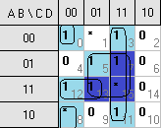

 | A | B | C | D | F
0 | 0 | 0 | 0 | 0 | 1
1 | 0 | 0 | 0 | 1 | ϕ
2 | 0 | 0 | 1 | 0 | 0
3 | 0 | 0 | 1 | 1 | 1
4 | 0 | 1 | 0 | 0 | 0
5 | 0 | 1 | 0 | 1 | 1
6 | 0 | 1 | 1 | 0 | 0
7 | 0 | 1 | 1 | 1 | 1
8 | 1 | 0 | 0 | 0 | ϕ
9 | 1 | 0 | 0 | 1 | 0
10 | 1 | 0 | 1 | 0 | 0
11 | 1 | 0 | 1 | 1 | 1
12 | 1 | 1 | 0 | 0 | 1
13 | 1 | 1 | 0 | 1 | 1
14 | 1 | 1 | 1 | 0 | 0
15 | 1 | 1 | 1 | 1 | ϕ
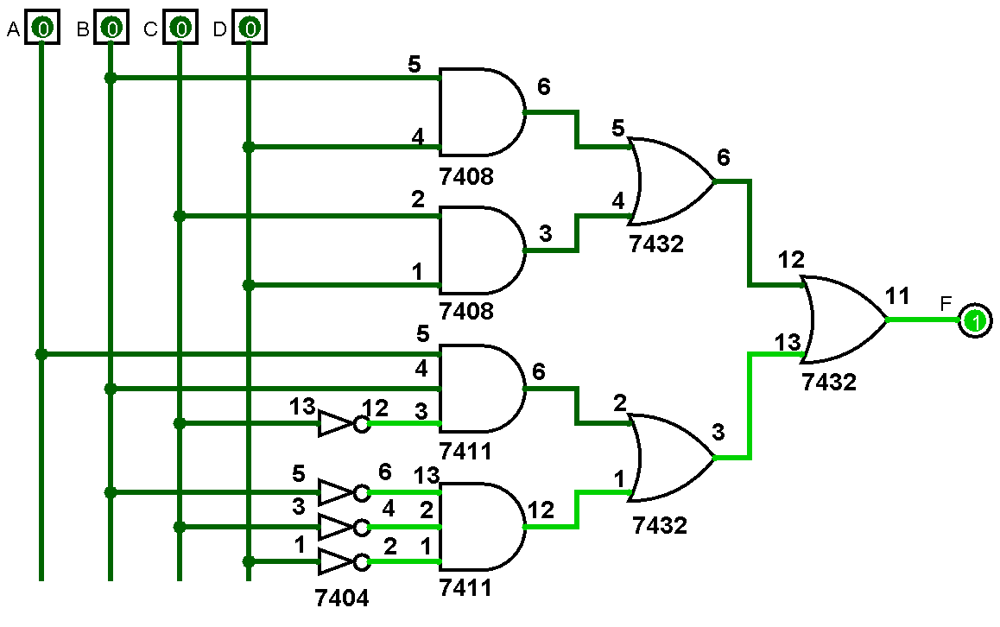

Experiment #2

F(A,B,C,D) = [(B↓D) ↓(C↓D)]’↓[(A↓B↓C’)↓(B’↓C’↓D’)]’

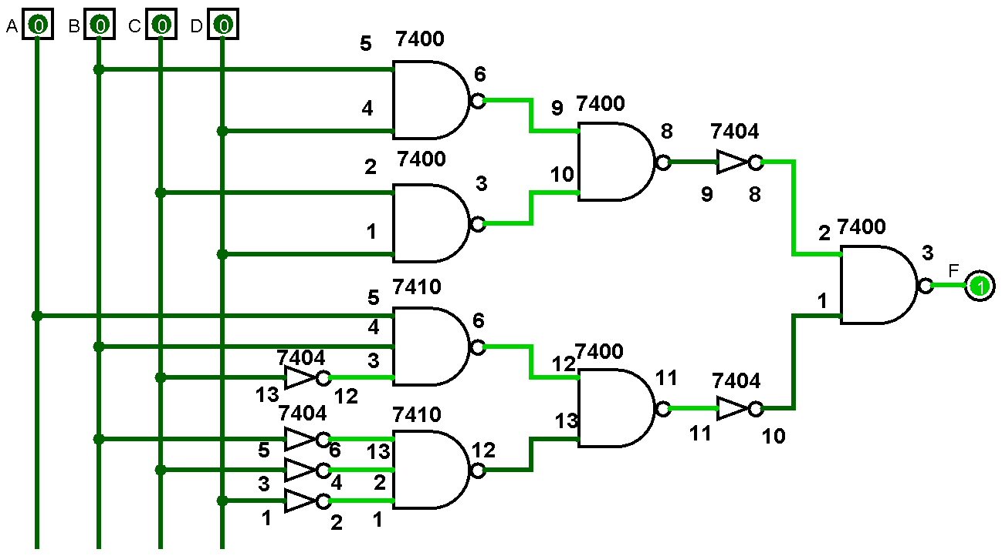

Experiment #3

 | A | B | C | D | F | MUX
0 | 0 | 0 | 0 | 0 | 1 | 1
1 | 0 | 0 | 0 | 1 | ϕ | 1
2 | 0 | 0 | 1 | 0 | 0 | D
3 | 0 | 0 | 1 | 1 | 1 | D
4 | 0 | 1 | 0 | 0 | 0 | D
5 | 0 | 1 | 0 | 1 | 1 | D
6 | 0 | 1 | 1 | 0 | 0 | D
7 | 0 | 1 | 1 | 1 | 1 | D
8 | 1 | 0 | 0 | 0 | ϕ | 0
9 | 1 | 0 | 0 | 1 | 0 | 0
10 | 1 | 0 | 1 | 0 | 0 | D
11 | 1 | 0 | 1 | 1 | 1 | D
12 | 1 | 1 | 0 | 0 | 1 | 1
13 | 1 | 1 | 0 | 1 | 1 | 1
14 | 1 | 1 | 1 | 0 | 0 | 0
15 | 1 | 1 | 1 | 1 | ϕ | 0

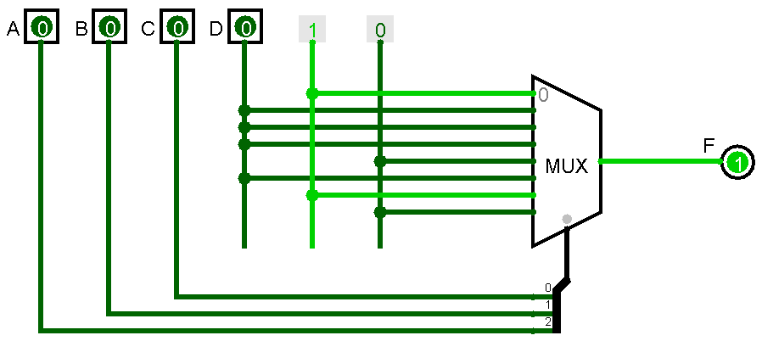

Experiment #4

F₁(A,B,C) = A’.C’ + B.C
F₁(A,B,C) = (A.B.C’ + A’.B’.C’) + (A.B.C + A’.B.C)

A | B | C | F
0 | 0 | 0 | 1
0 | 0 | 1 | 1
0 | 1 | 0 | 0
0 | 1 | 1 | 1
1 | 0 | 0 | 0
1 | 0 | 1 | 0
1 | 1 | 0 | 0
1 | 1 | 1 | 1

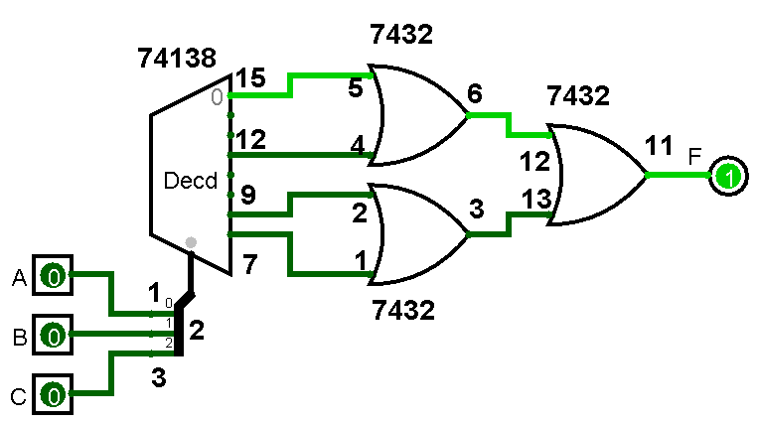

F₂(A,B,C) = A’.B’.C’ + A.B
F₂(A,B,C) = (A.B.C + A’.B’.C’) + (A.B.C’ + 0)

A | B | C | F
0 | 0 | 0 | 1
0 | 0 | 1 | 0
0 | 1 | 0 | 0
0 | 1 | 1 | 0
1 | 0 | 0 | 0
1 | 0 | 1 | 0
1 | 1 | 0 | 1
1 | 1 | 1 | 1

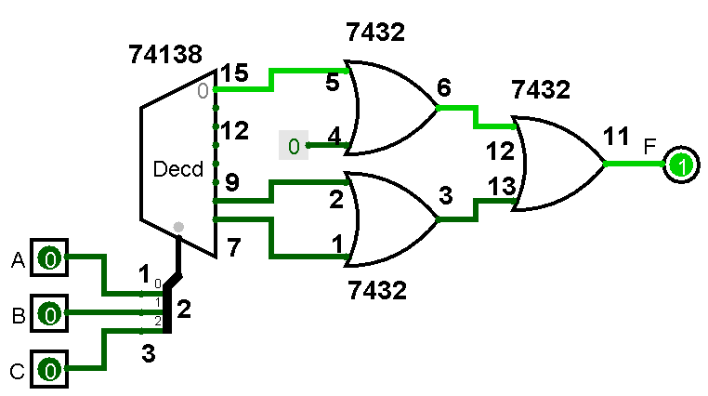

Answer of Question #3

F'(A,B,C,D) = A'·B'·C + A·C'·D' + B·D'

F'(A,B,C,D) = A'·B'·C.(D + D’) + A·(B + B’).C'·D' + (A + A’).B·(C + C’).D'

F'(A,B,C,D) = A'·B'·C.D + A'·B'·C.D’ + A·B.C'·D' + A.B’.C'·D' + A.B.C.D’ + A.B.C’.D’ + A’.B.C.D’ + A’.B.C’.D’

F'(A,B,C,D) = ∑m(4,6,8,10,11,12,14)

F'(A,B,C,D) = ΠM(0,1,2,3,5,7,9,13,15)

F'(A,B,C,D) = (A + B + C + D).(A + B + C + D’). (A + B + C’ + D).(A + B + C’ + D’). (A + B’ + C + D’).(A + B’ + C’ + D’). (A’ + B + C + D’).(A’ + B + C’ + D’). (A’ + B’ + C’ + D’)
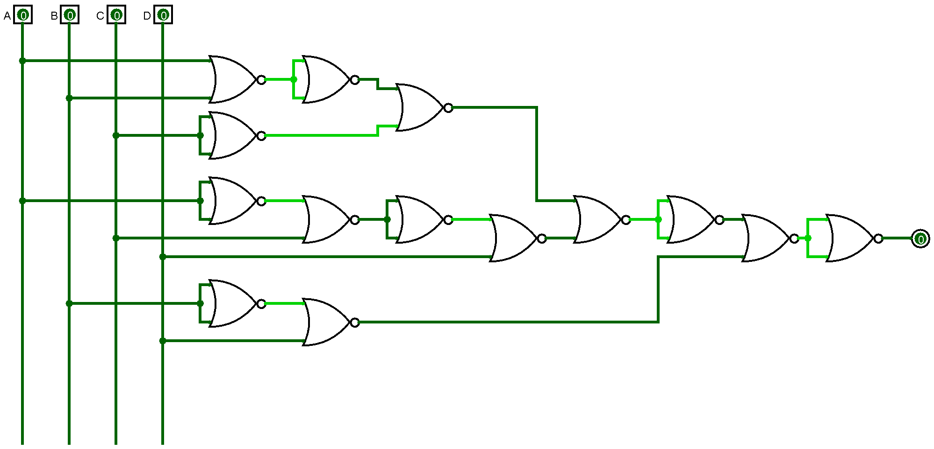

Answer of Question #4

